Calum Hodges
AHVS 498
March 2024

Translation and Heterogeneity revisited

The statement “The mid- to late-twentieth century saw the emergence of new art
forms and new approaches that increasingly opened up ideas such as ‘relational aesthetics’ and
art as ‘translation’ [p.189]. There was an increased emphasis on art within a complex social
matrix of human interaction.” In our discussions, we noted how art shifted heavily in line with post-war society, and a response to trauma. Thus, resulting in relational aesthetics. For example, as discussed in the chapter, the emergence of abstraction “...was a way of re-asserting art’s apparent integrity as a culturally independent practice” (Harris 1994: 35, p. 168). I found these ideas very interesting, as it showcases how art and society shift simultaneously, and how art is no longer simply making then selling something, but the act of creating and the emergence of performance art has been massively popularized. Revisiting art as translation has allowed myself to better grasp how art works in parallel with society, and as one shifts, the other shortly follows. I think to the mid 20th century, with the emergence of new art forms in a response to global conflict and trauma, such as Cubism, Abstract Expressionism, and so on. While we commonly think of art as a response to society, I believe art is a reflection of society and the collective mind. Artistic shifts did not happen solely because society shifted, too, rather artistic shifts can come before society shifts (art acts as a harbinger of the shift to come). An example of this is modern art, beginning in the 1860/70s. Modern art, to this day, can be incredibly confusing, with many having a hard time even calling some examples of modern art, art. I would argue that modern art happened before any true modern shift in society, acting as the precursor to the societal shift itself.
Heterogeneity; mobility; etc. are all relatively new terms for me in the scope of Art History. Specifically heterogeneity (mostly because I wanted to look into this more as our group struggled with defining it), as in the context of art history, heterogeneity is the presence of a wide range of elements in artistic movements, styles, and periods. It captures the wide range of philosophies, methods, and expressions that coexist to weave a complex tapestry of artistic development. This diversity can be shown in the variations in subjects, media, influences from different cultures, and viewpoints of individual artists. Heterogeneity highlights the intricacy present in the artistic landscape and challenges oversimplified classifications. As artists interact with a diverse range of influences and continually reshape the artistic narrative, it represents the dynamic interplay between innovation and tradition. In art history, heterogeneity celebrates the diversity of viewpoints and creates an atmosphere that encourages creativity in all of its manifestations. This stands out to me because of this non-static, dynamic, and unparalleled diversity of art in our lives.
I really enjoyed exploring simulacra/crum as an exploration of how massively popular media such as Mickey Mouse (as Wynn stated) are in everyone's head, we have an idea of it, but they all exist independently even though it is a sort of shared knowledge. This shared knowledge is then repeated in public spaces, like disneyland. In turn we can look at collaboration and how nowadays collaboration is basically just commercialization for well known brands or artists. I really liked Wynn’s example of KAWS (Brian Donnely), which has collaborated with musicians like Kanye and Pharrell to high end fashion lines like Dior and Comme Des Garcons to everyday apparel brands like Uniqlo and Nike. Philosophical ideas such as simulacra and simulacrum have been poignantly expressed in a variety of artistic mediums, prompting spectators to reevaluate the nature of authenticity and representation. One of the best examples is René Magritte's "The Treachery of Images" (1929), which shows a painting of a pipe with the words "Ceci n'est pas une pipe" (This is not a pipe) underneath it to remind viewers that this is only an image and not the real thing. In order to highlight the pervasiveness of identical, mass-produced goods, Andy Warhol presented replicas of the original soup cans in his famous Campbell's Soup Cans (1962) series, which reflected on mass production and consumer culture. Marcel Duchamp's provocative "Fountain" (1917), an anonymously signed urinal, subverts conventional ideas of art by presenting a utilitarian item as art.
https://kawstoo.com/kaws-collaborations/

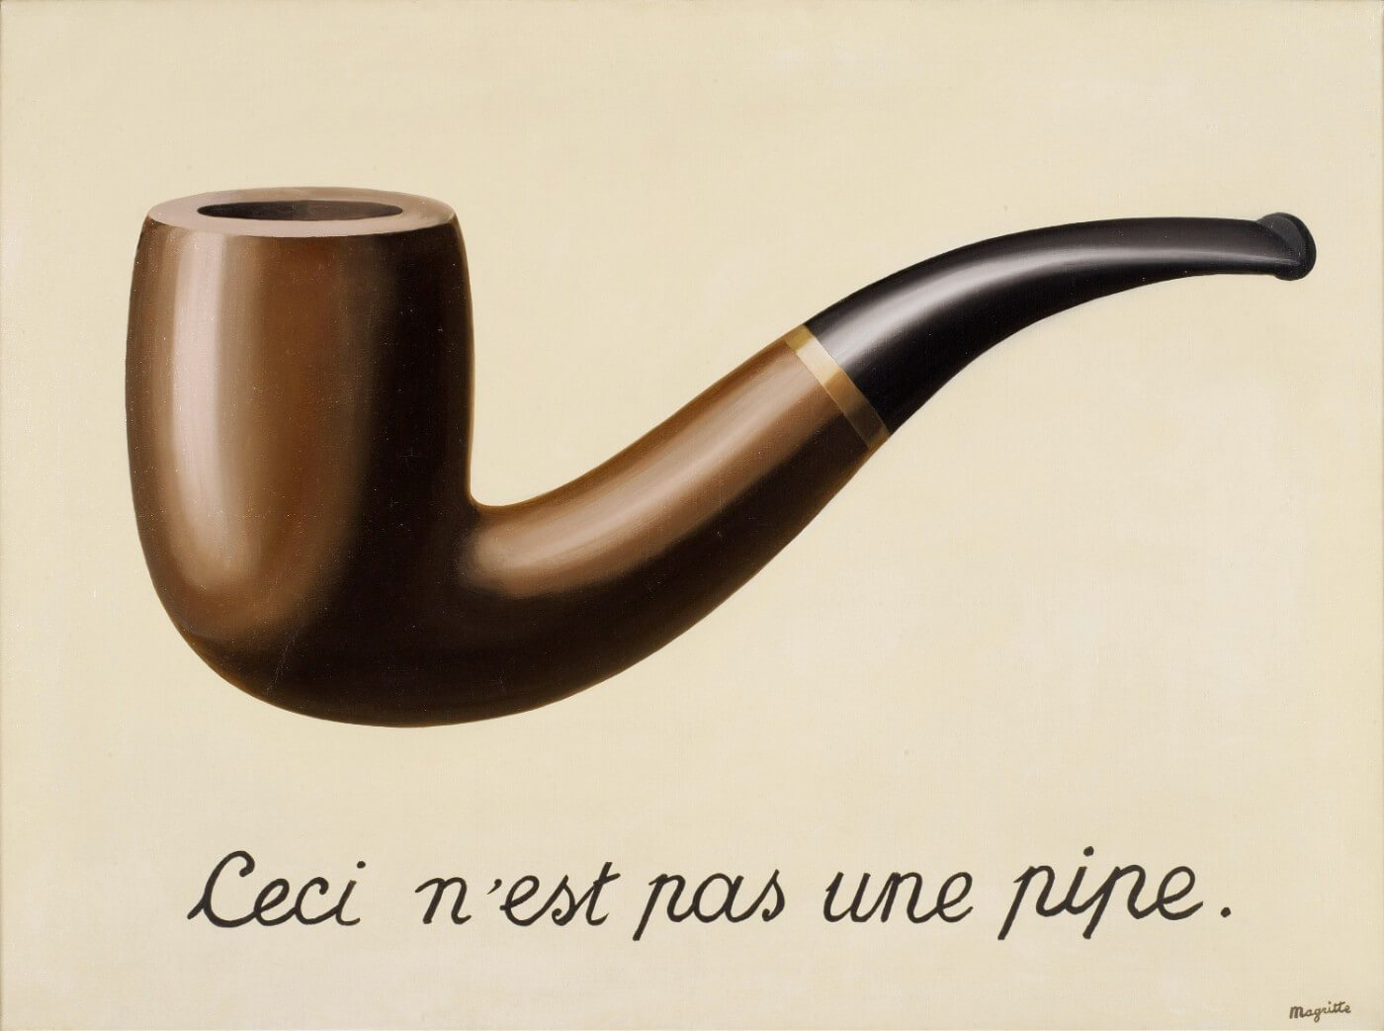

René Magritte, The Treachery of Images, (1929), oil paint, 60.33 cm × 81.12 cm, Los Angeles County Museum of Art, Private collection.

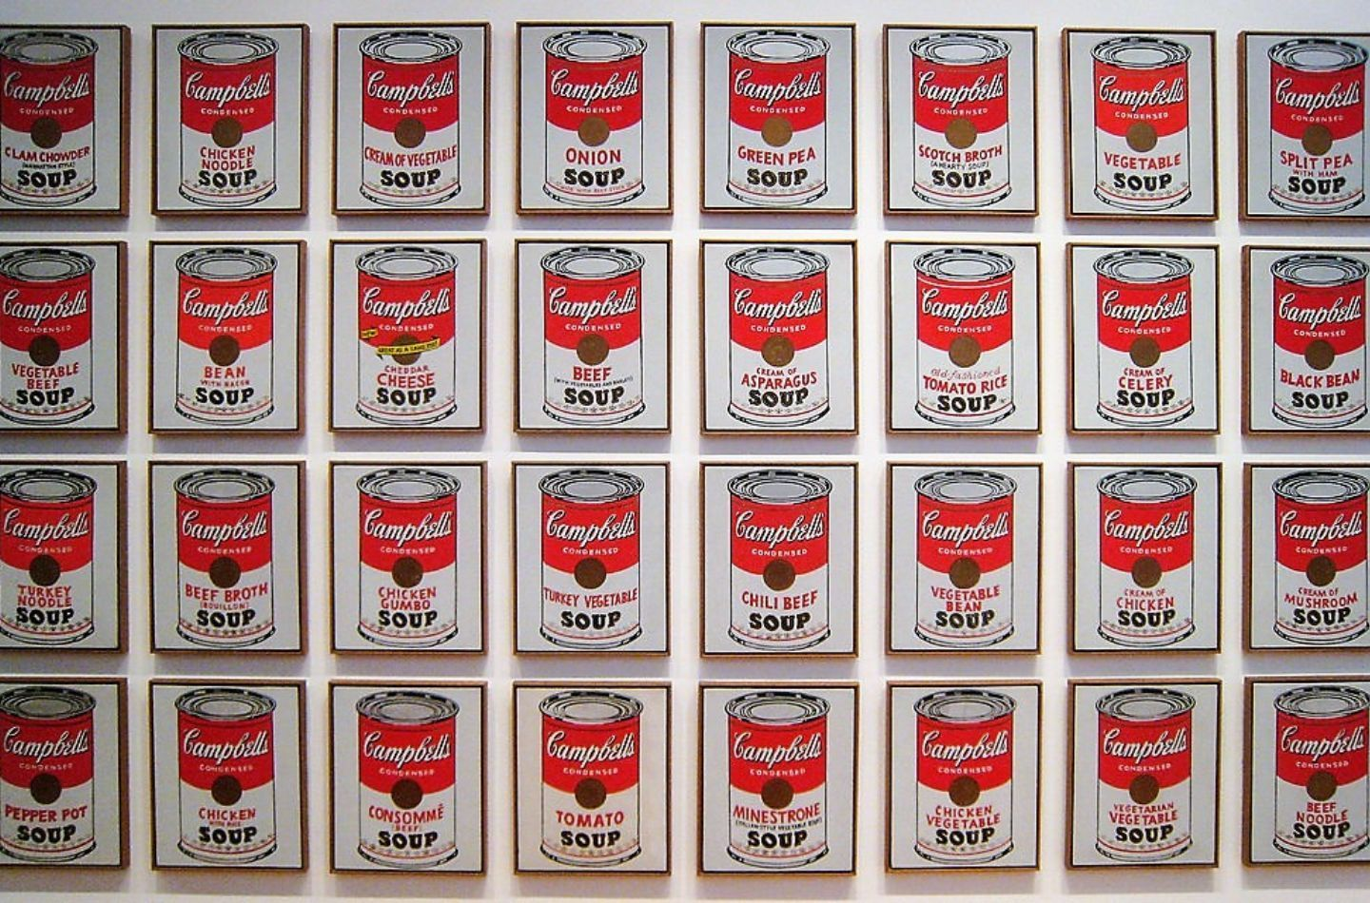

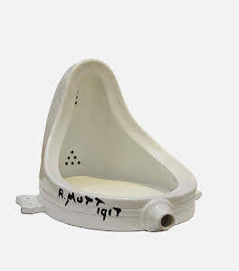
Andy Warhol Campbell Soup Cans (1962), Acrylic with metallic enamel paint on canvas, 32 panels, each canvas 50.8 x 40.6 cm, The Museum of Modern Art.

Marcel Duchamp, Fountain, (1917), Ceramic, glazed ceramic, original is lost.
Calum Hodges
AHVS 498
March 2024

References

Hall, James. n.d. “‘Fountain‘, Marcel Duchamp, 1917, replica 1964.” Tate. Accessed March 9, 2024. https://www.tate.org.uk/art/artworks/duchamp-fountain-t07573.

Rockefeller, Nelson A., and William A. Burden. n.d. “Andy Warhol. Campbell's Soup Cans. 1962.” MoMA. Accessed March 9, 2024. https://www.moma.org/collection/works/79809.

“The Treachery of Images, 1929 by Rene Magritte The Treachery of Images, 1929 by Rene Magritte.” n.d. Rene Magritte. Accessed March 9, 2024. https://www.renemagritte.org/the-treachery-of-images.jsp.

