Calum Hodges
AHVS 498
March 2024
Revisiting Formalism

Through analyzing Diana Newall and Grant Pooke’s breakdown of formalism as well as tapping into my pre-existing notions/understanding toward formalism, I understand the term as placing emphasis on the composition, colour, line, shape, and texture of an artwork rather than emphasizing the piece's social, historical, or cultural background. By grasping this definition of formalism, one can start to unfold how this may become utilized in an art history sense. While art history typically covers what is excluded by formalism (social, historical, cultural background), understanding the physical forms/ composition of the artwork is a necessity to shape a more balanced idea of what the artwork may actually be. Understanding styles and form can also assist art historians by being able to lock in the time and place of creation of the artwork, beneficial for curation and exhibitions. Furthermore, through the class discussions, my group and I agreed that understanding a work's formal elements is the very first step we often take when conducting our own research, and how beneficial it is to understand the artists physical work before delving into the history of it. Thus, by examining the composition, deeper connections can be made that assist art historians in placing the work under a certain genre, time/space, or even geographical location. If I were given an artwork with zero context behind it and no pre-existing knowledge of the artist I would rely on the formal elements. In revisiting this, my understanding of formal elements has increased, and (in my opinion) I still believe that having a grasp of the formal elements of an artwork is a necessity and perhaps the most objective way of viewing the most subjective topic on earth.
Modernism and modernity are two of perhaps the most common terms referenced among the classes I have taken in art history and visual studies. My understanding and definition of it within the scope of art history is that modernism is used to describe a wide range of intellectual, artistic, and cultural movements that began in the late 19th century and peaked in the early to mid-20th century. It was a reaction to the political, social, and technological shifts of the time and are characterized by a sort of separation from the norm and break from tradition. This came in forms such as Cubism, Futurism, Dadaism, Surrealism, Abstract Expressionism, and so much more. These movements under the term modernism were all a deliberate separation from conventional forms of artistic expression and creation, and one of the best examples of using artwork in a political sense, or rather a discussion of the state of society. As discussed in Chapter 2 and noted by American art critic Clement Greenberg, “Greenberg’s concept of modernism was marginalised by the shift from abstraction and two-dimensional art which characterised the later 1960s (Newall & Pooke, pg. 52, 2021). While Greenberg’s understanding of modernity has been critiqued and is no longer largely discussed, his main takeaways- such as the step away from tradition, are important topics in which all art historians must have some form of understanding of. Throughout the chapter, I found my prior understanding of both formalism and modernity to be reinforced through the explorations and examples of real life usage of these terms. And, through the in-class discussions, I found that narrowing in on one specific movement is beneficial for gaining an understanding of terms such as modernism- such as abstract expressionism (our focus). I have added a few examples of artworks that follow this separation of traditional form, and I urge those reading this to think about how these artists took a technical skill and turned it into an expression rather than simply a series of calculated lines, shapes, textures, etc. These examples, different from those previously posted, are examples of artworks that require and insist upon composition and formal elements. If one cannot understand an artwork that requires it to be understood, it is difficult to have an opinion or be able to create an analysis of the work. This is crucial for an art historian.
In summary, formalism in art emphasizes the formal elements of an artwork over its social, historical, or cultural context, aiding in a balanced interpretation. Modernism describes various movements that emerged as a reaction to societal changes, characterized by a departure from traditional artistic expression. These concepts are foundational in art history and visual studies, offering valuable insights into the evolution of art and culture.
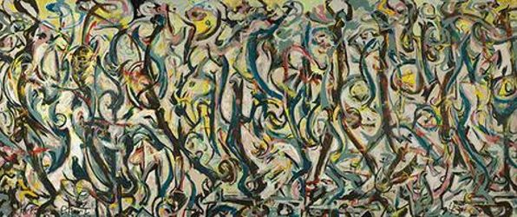

Jackson Pollock, Mural (1943), oil paint on linen, 243 cm × 604 cm, Stanley Museum of Art

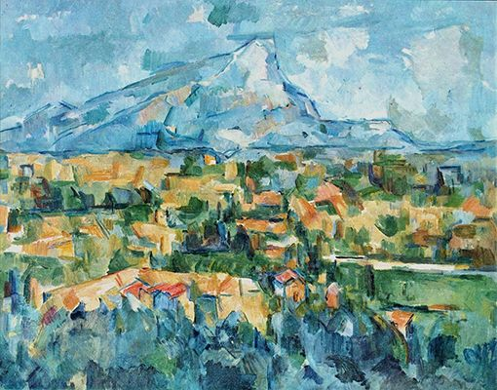

Paul Cézanne, Mont Sainte-Victoire, (1904), Oil on canvas, 57.2 x 97.2 cm, The Philadelphia Museum of Art, Philadelphia

Calum Hodges

References
“Formalism in Modern Art - Modern Art Terms and Concepts.” n.d. The Art Story. Accessed March 8, 2024. https://www.theartstory.org/definition/formalism/.

